USER MANUAL

UBOLD POS AND ERP

ICBT KANDY CAMPUS

CSE5015

Table of Contents

Login 2

Dashboard 3

Profile 4

Employee Management 6

Customer Management 10

Supplier Management 14

Employee Salary 19

Employee Attendance 22

Category Management 25

Product Management 28

Expense Management 33

POS 35

Order Management 44

Stock Management 48

Role and Permissions 51

Setting Admin Users 61

Database Backup 66

# Login

The 1st page that will appear when the user opens the web-based ERP. In here please enter the email address and password the administrator gave.

Once successfully logged in dashboard will appear.

All the available functionalities will appear in the sidebar of the web application.

# Dashboard

Dashboard Shows that day’s statics.

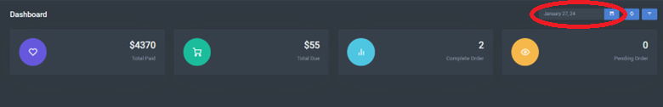

In here Total Sales can be seen as per that day.

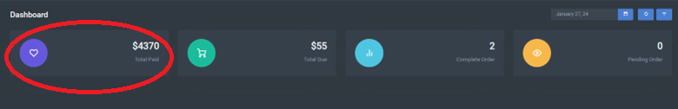

In here Total Due can be seen.

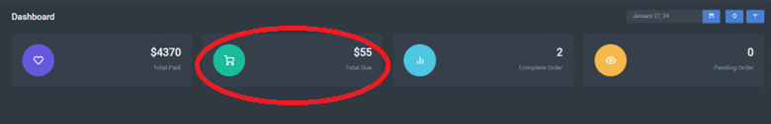

In here number of Completed Orders can be seen.

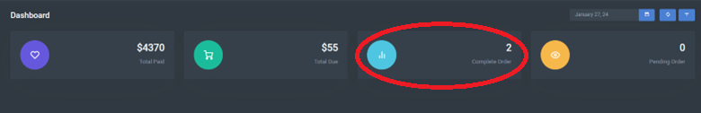

In here number of Pending Orders can be seen.

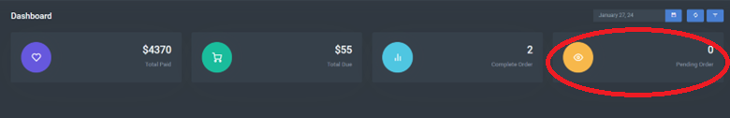

# Profile

Once logged in go to My Account Section as follows.

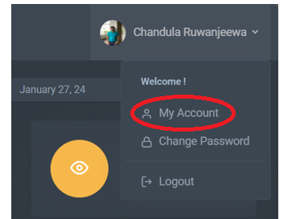

Then details can be updated by editing the current records as follows.

If the user wants to update the password assigned by the administrator, go to change password as follows.

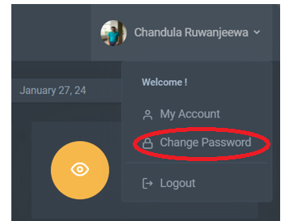

In here enter the current password and new password and then confirm it.

# Employee Management

To go to employee management, select Employee Manage on Sidebar.

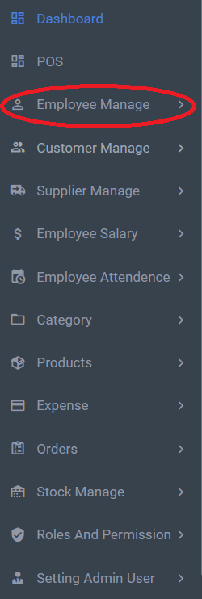

Employees can be added as follows.

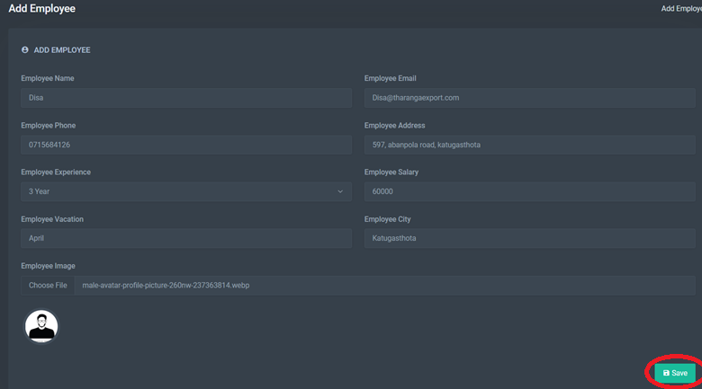

All the added employees will be seen as this.

To search for employees, enter the details that you need to search for.

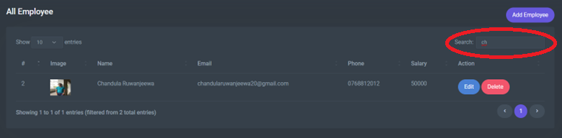

To Edit employee data, click the edit button on All Employees.

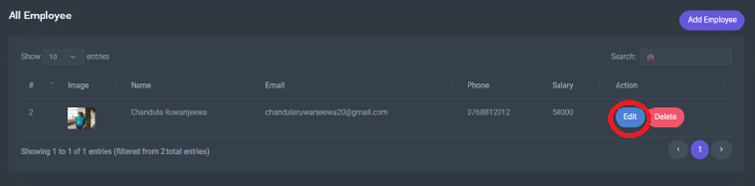

Then update the existing data and click save button.

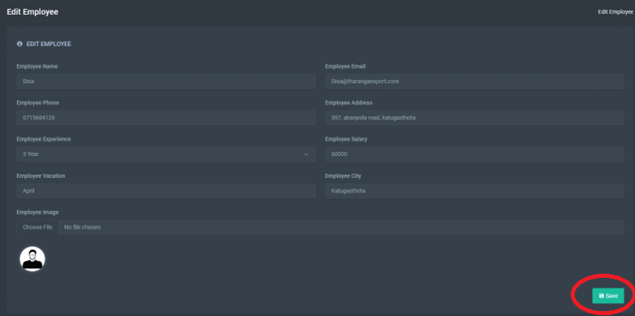

To delete an employee from the system, click the delete button from all employees and click Yes to delete.

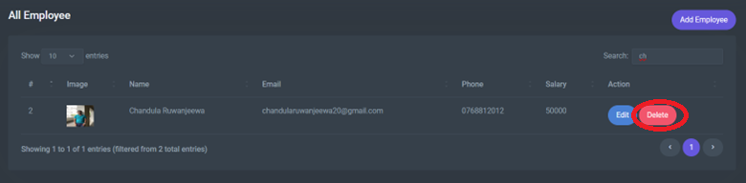

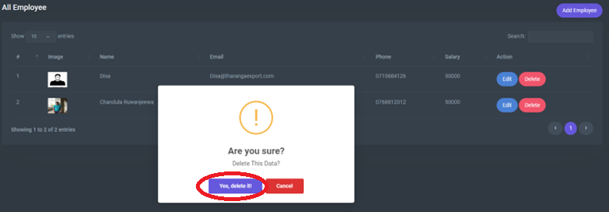

# Customer Management

To go to customer management, select Customer Manage on Sidebar.

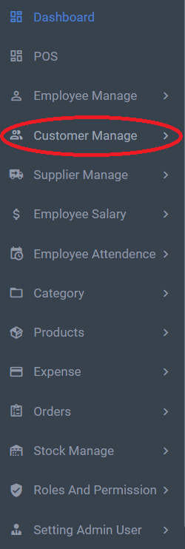

Customers can be added as follows.

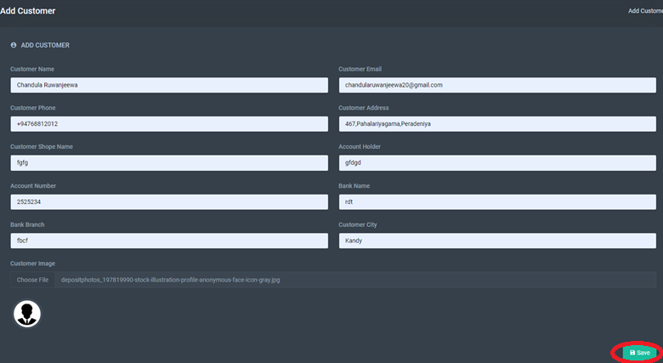

All the added customers will be seen as this.

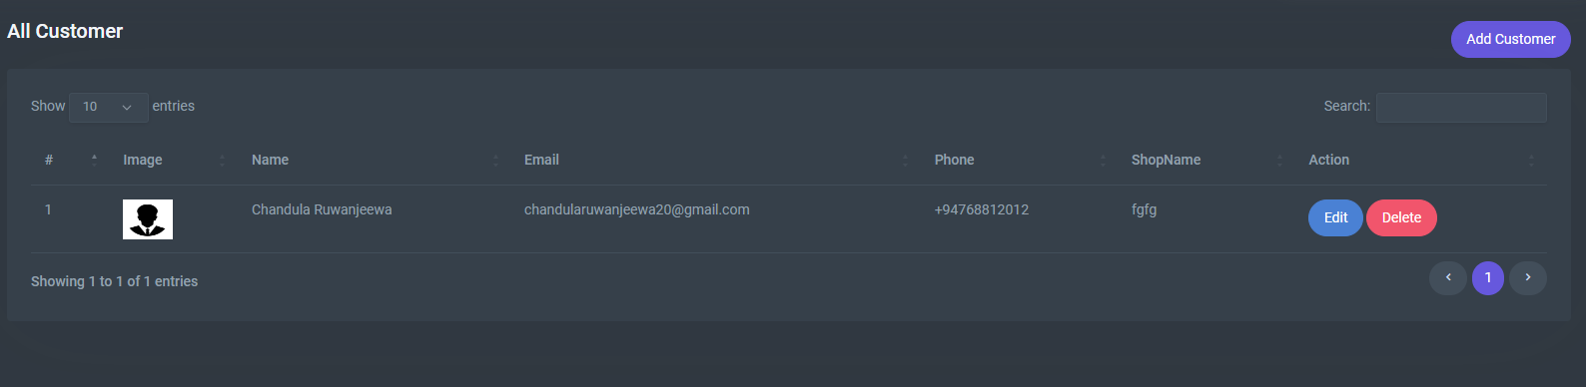

To search for a customer, enter the details that you need to search for.

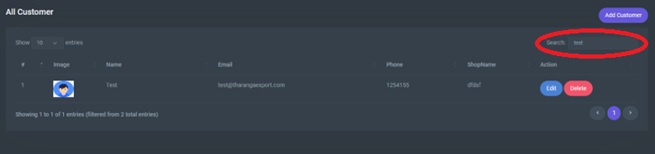

To Edit customer data, click the edit button on All Customers.

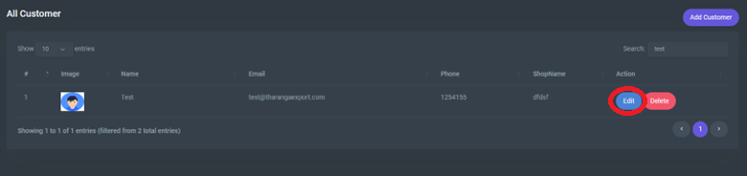

Then update the existing data and click save button.

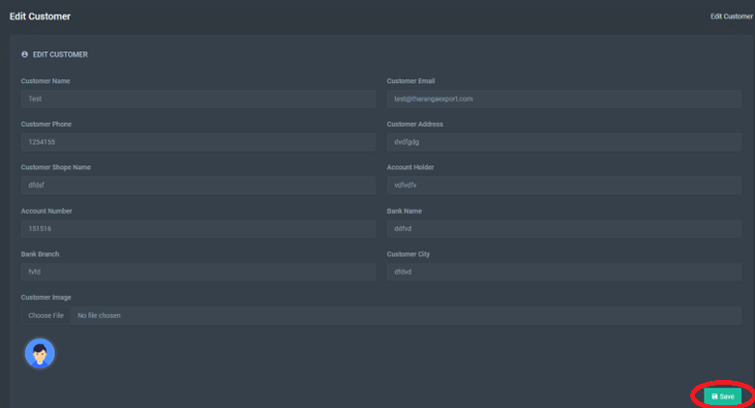

To delete a customer from the system, click the delete button from all customers and click Yes to delete.

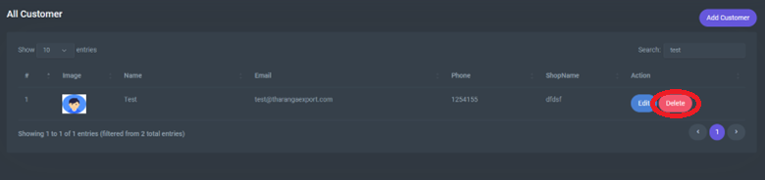

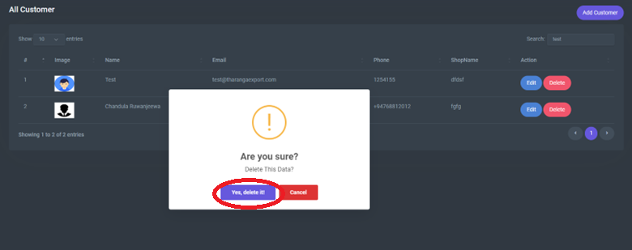

# Supplier Management

To go to supplier management, select Supplier Manage on Sidebar.

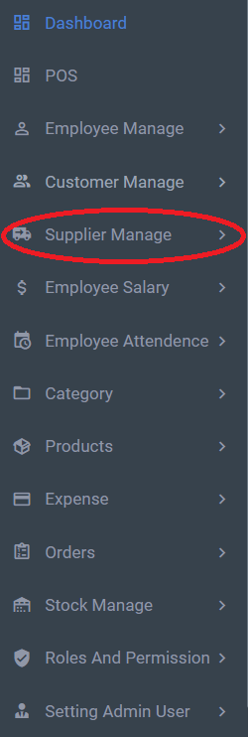

Suppliers can be added as follows.

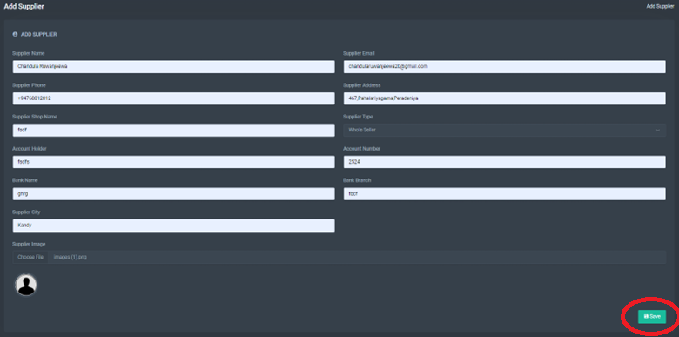

All the added suppliers will be seen as this.

To search for a supplier, enter the details that you need to search for.

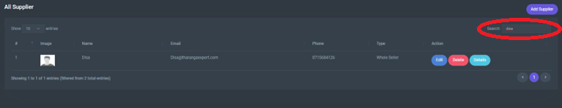

To Edit supplier data, click the edit button on All Suppliers.

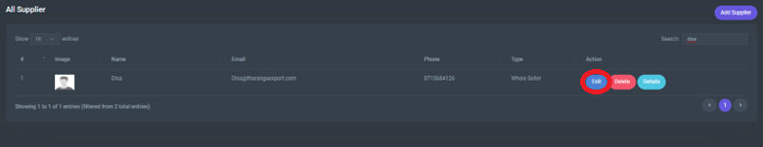

Then update the existing data and click save button.

To view supplier data, click the details button on All Suppliers.

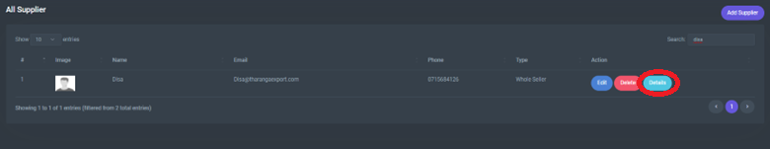

To delete a supplier from the system, click the delete button from all suppliers and click Yes to delete.

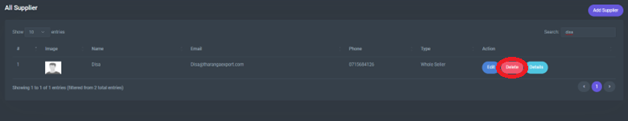

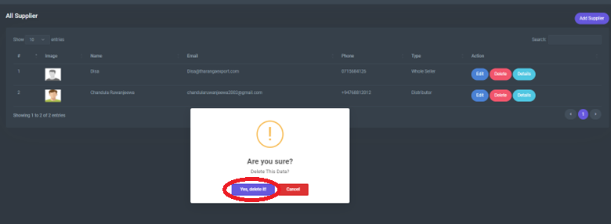

# Employee Salary

To add employee salary, go to Employee Salary from the sidebar to add advance salary.

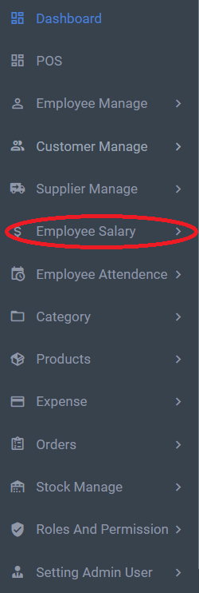

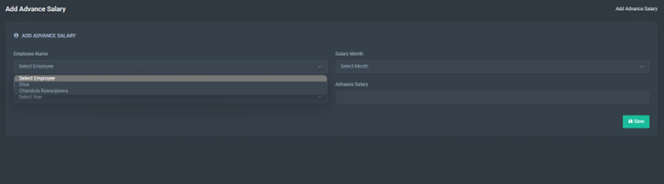

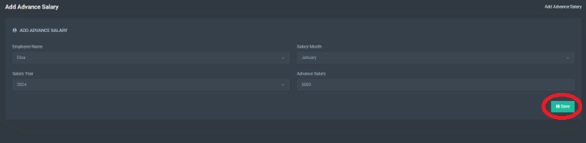

All the added advance salaries will be seen as this.

To search for an advance salary, enter the details that you need to search for.

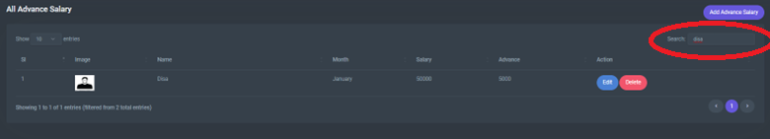

To Edit advance salary data, click the edit button on All Advance Salary.

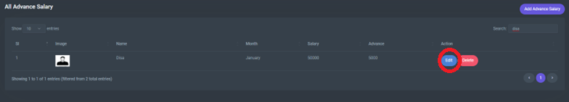

Then update the existing data and click save button.

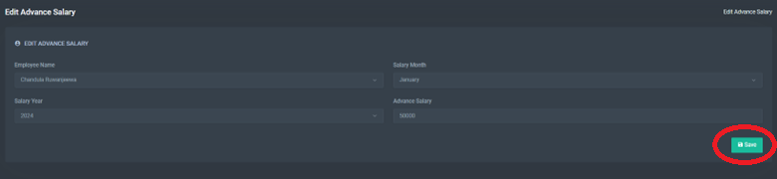

To delete an advance salary from the system, click the delete button from all advance salary and click Yes to delete.

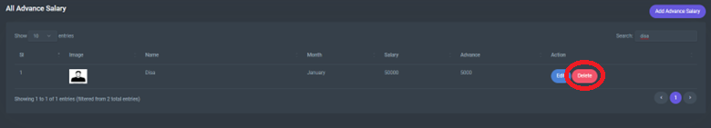

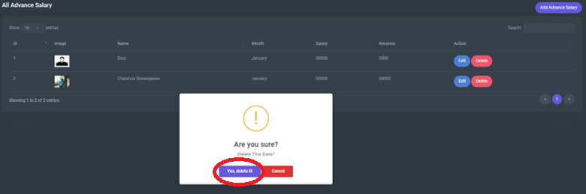

# Employee Attendance

To add employee attendance, go to Employee Attendance from the sidebar to all advance salary.

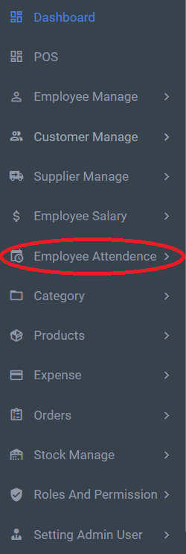

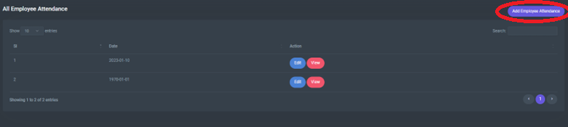

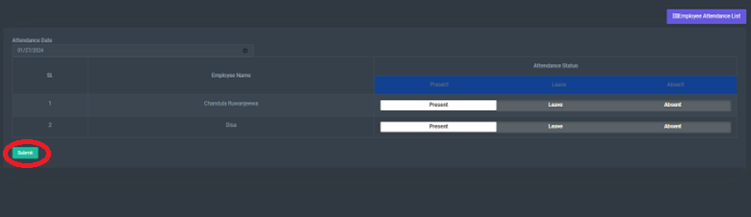

To Edit employee attendance data, click the edit button on All Employee Attendance.

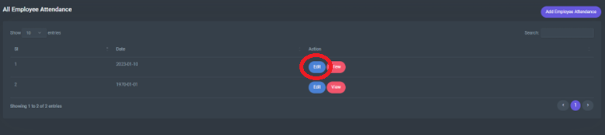

Then update the existing data and click the update button.

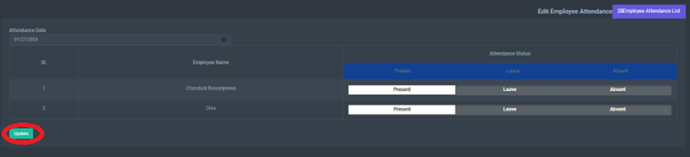

To View employee attendance data, click the view button on All Employee Attendance.

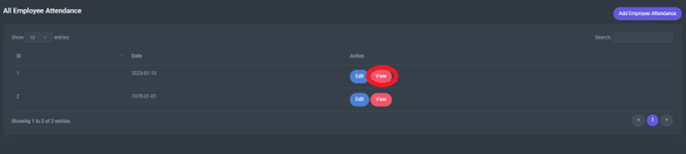

# Category Management

To add category, go to Category from the sidebar to all categories.

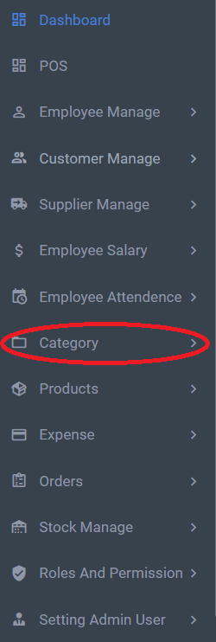

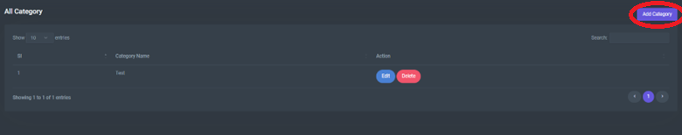

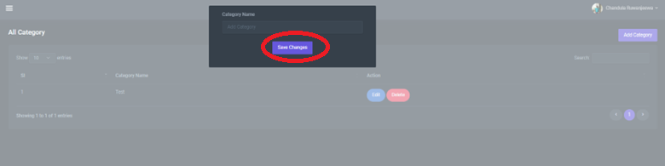

To search for a category, enter the details that you need to search for.

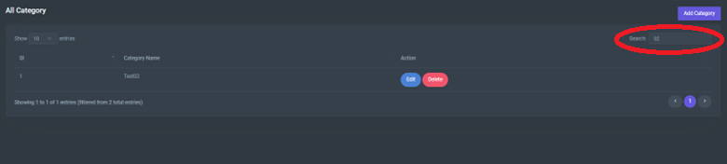

To Edit category data, click the edit button on All Category.

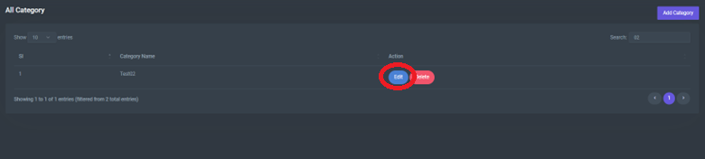

Then update the existing data and click save button.

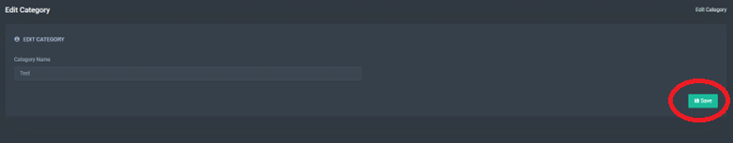

To delete a category from the system, click the delete button from all categories and click Yes to delete.

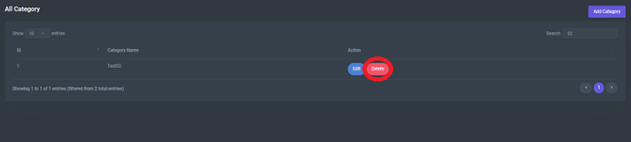

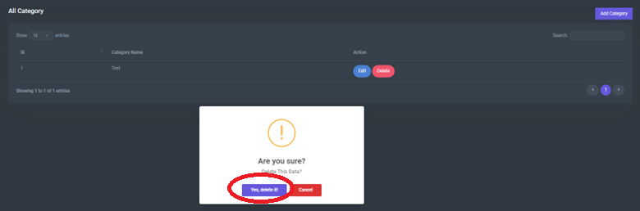

# Product Management

Go to Category from the sidebar to all Products.

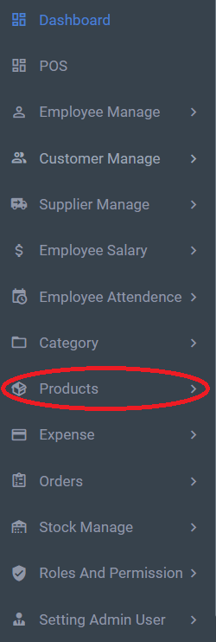

Products can be added as follows by clicking the save button at last.

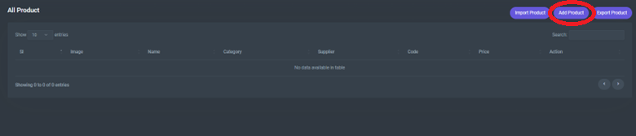

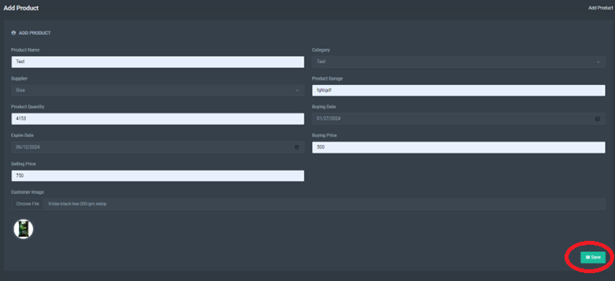

To search for a product, enter the details that you need to search for.

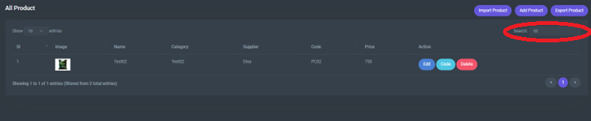

To get the product code and barcode, click the view button in All Product.

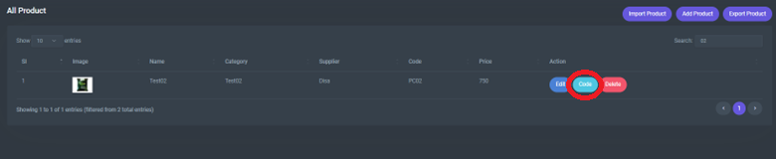

To Edit product data, click the edit button on All Product.

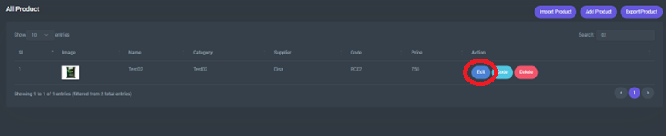

Then update the existing data and click save button.

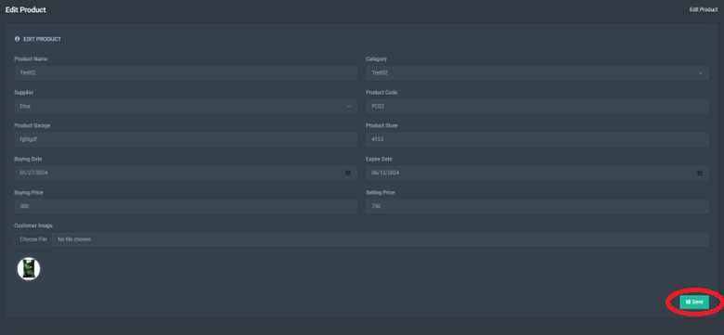

To delete a category from the system, click the delete button from all categories and click Yes to delete.

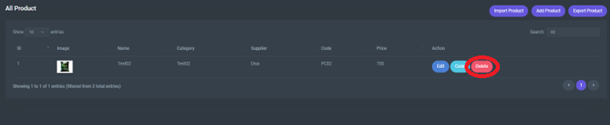

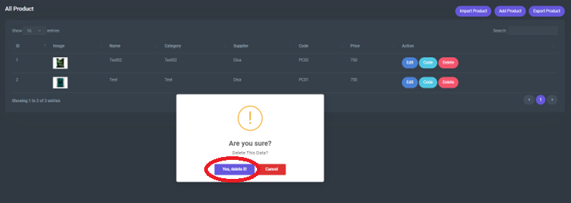

To export product details from the system to excel file, click the export button from all products.

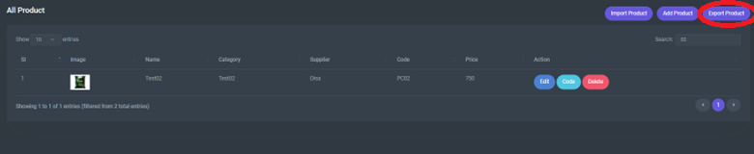

To import product details to the system to excel file, click the import button from all products.

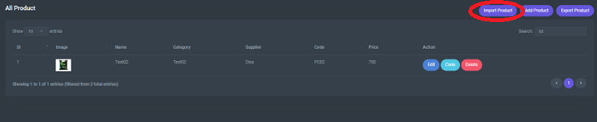

# Expense Management

Go to Expense from the sidebar.

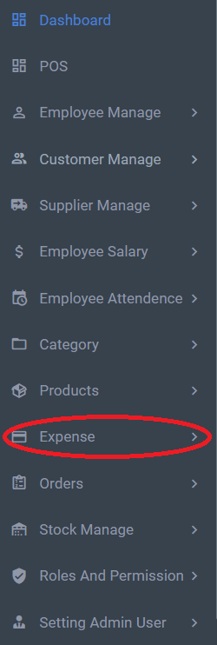

To add expense, go to add expense from the sidebar.

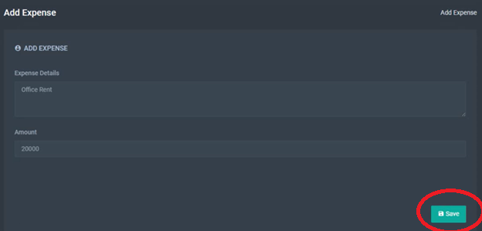

# POS

Go to POS from the sidebar.

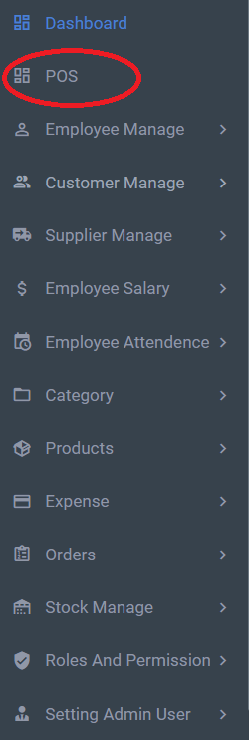

Search from products area to find the required product.

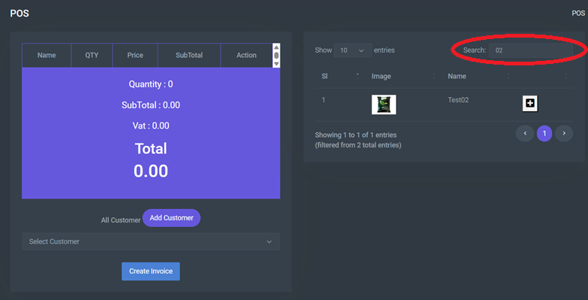

Click the plus icon to load products to cart.

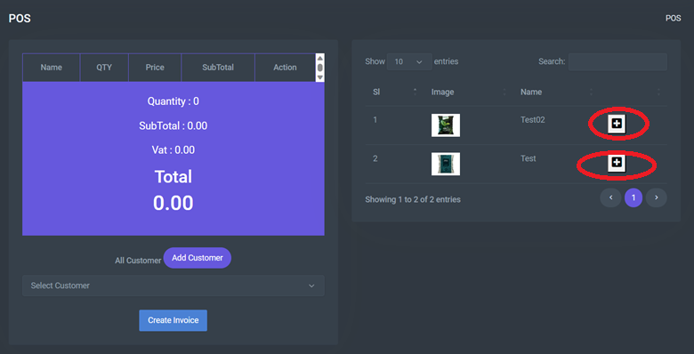

Select the Customer from the Dropdown.

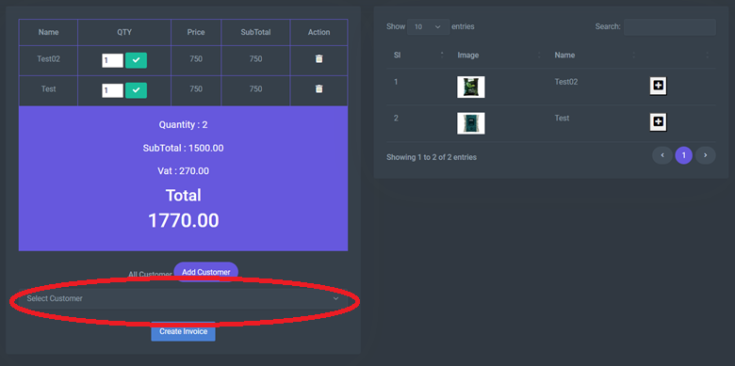

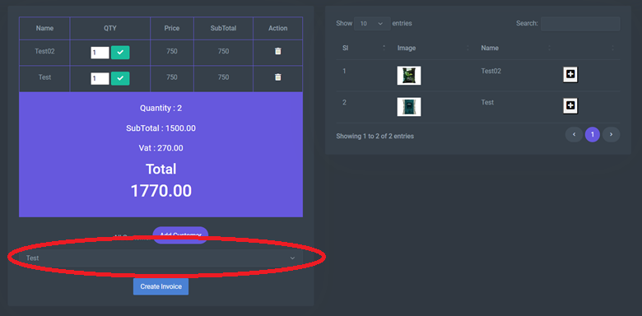

If need to add a customer click Add Customer button view goes to add customer page.

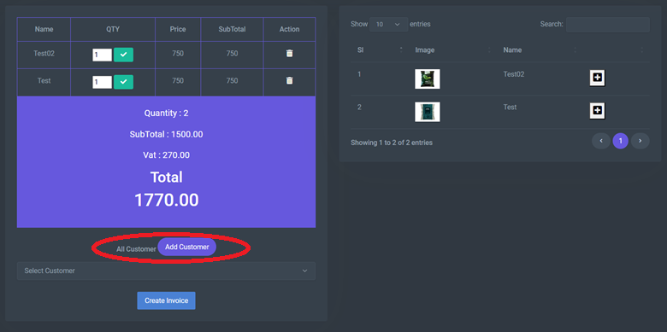

After selecting the customer click on Create Invoice to get the invoice.

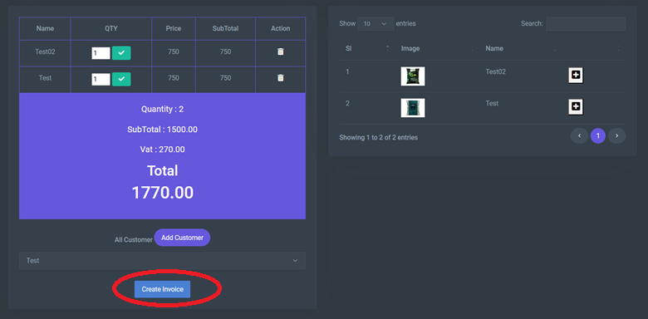

After getting the invoice Click Create Invoice to place the order.

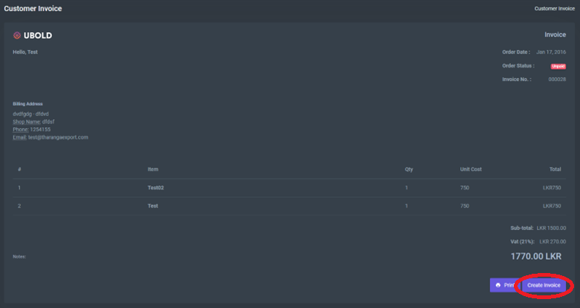

Then choose the payment method from the popup.

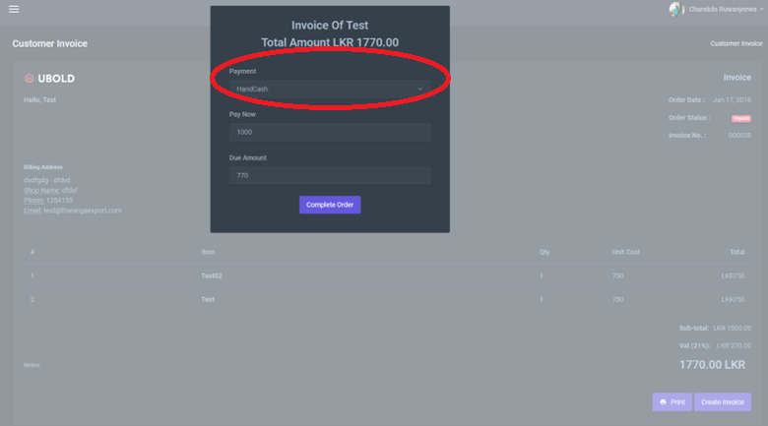

Then add the initial and due payments.

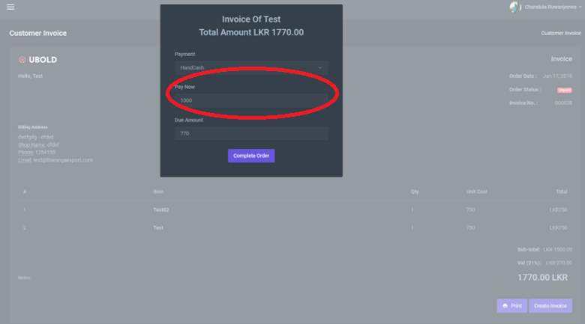

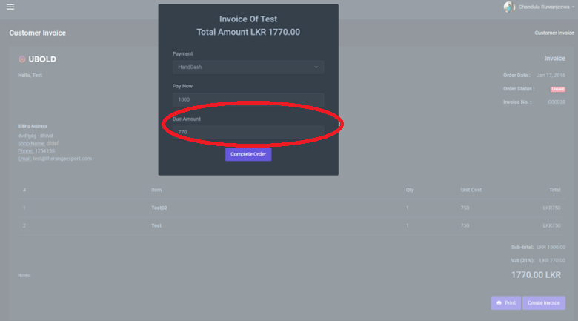

Then the cart will clear itself.

# Order Management

Go to Orders from the sidebar.

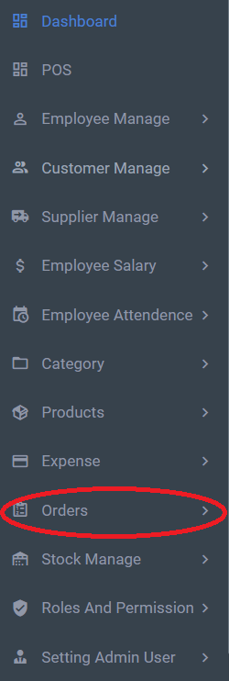

Go to Pending Orders from the sidebar to view all the Pending Orders.

Click on the Details button to view the order details and complete the order.

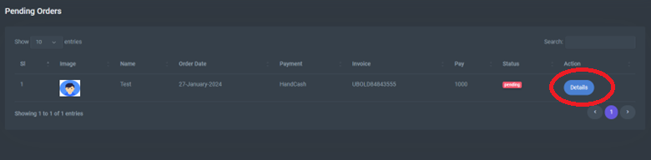

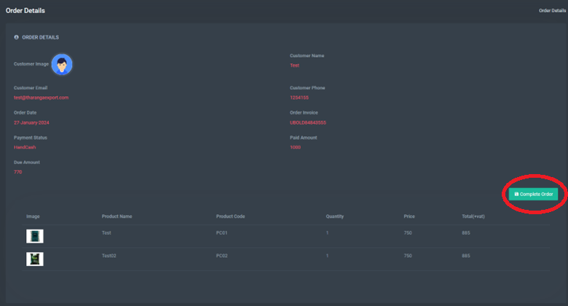

Then the pending order is transferred to complete orders. To get there go to Complete Orders from the sidebar to view all the Pending Orders.

To get the invoice for completed order will be as follows.

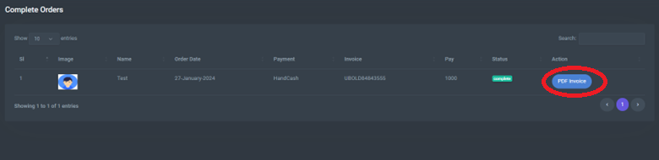

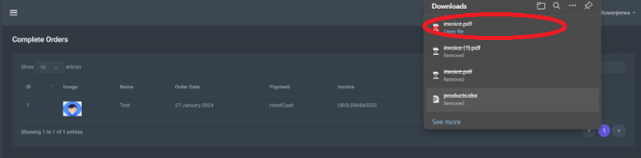

Once the order is completed. Go to pending Due from the sidebar. In here all the details regarding the payments can be found.

Once a customer settles a due payment it needs to be done as follows.

1st add the due payment amount.

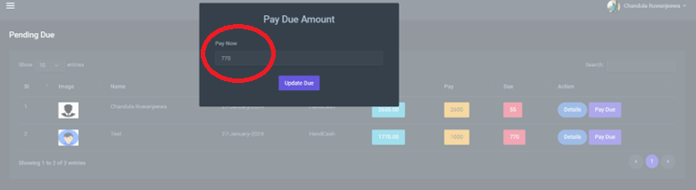

Then click on Update Due.

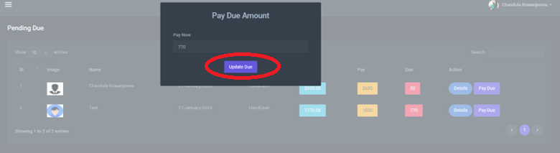

Orders can be searched as follows.

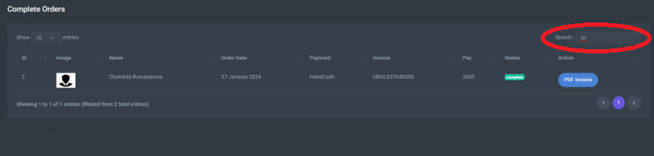

# Stock Management

Go to Stock Manage from the sidebar.

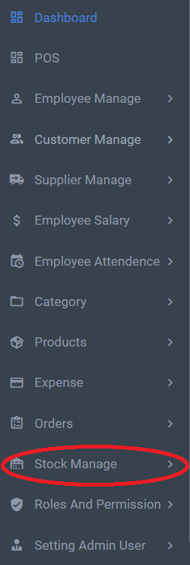

In Here current stock levels can be seen as follows.

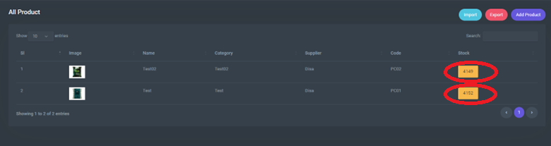

From here also new products can be added.

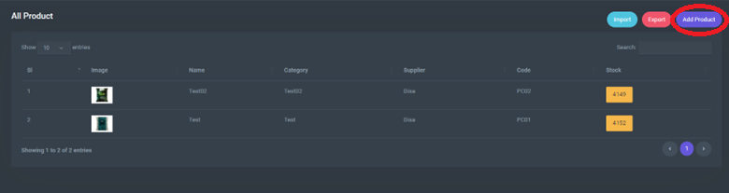

From here also products can be imported.

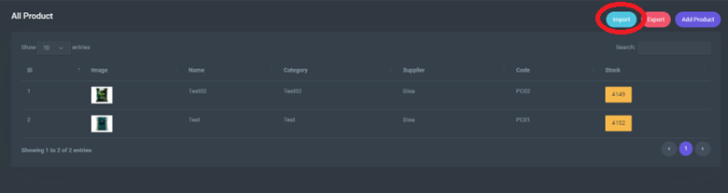

From here also products can be exported.

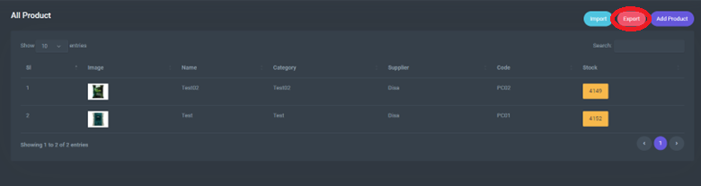

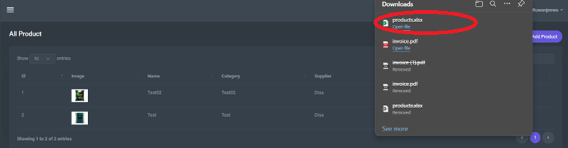

# Role and Permissions

Go to roles And Permissions from the sidebar.

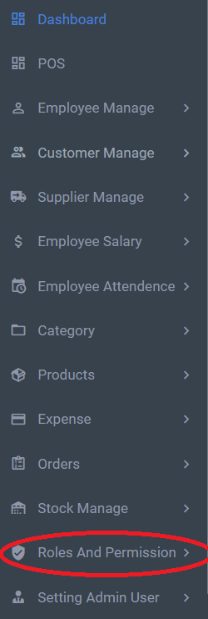

To view all the permissions, go to All Permissions from the sidebar.

To add new permissions click Add permission from All Permissions.

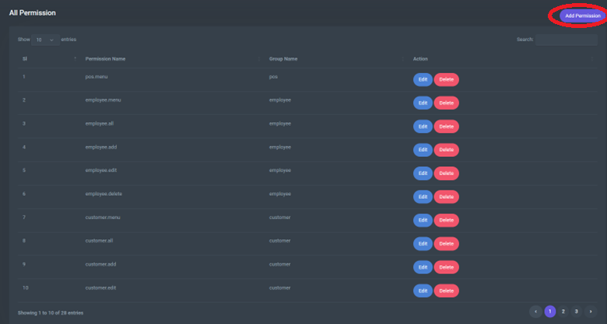

To edit permissions click Edit from All Permissions.

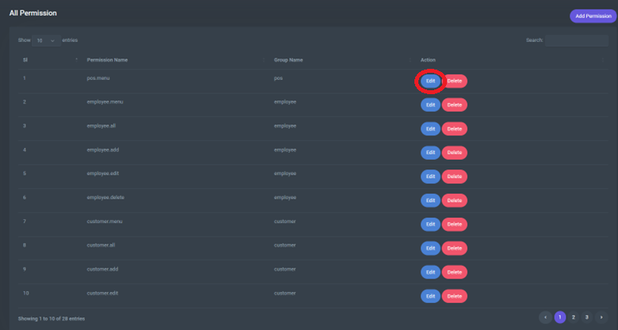

Update the existing data and click the save button.

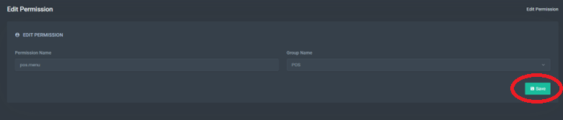

To delete a permission from the system, click the delete button from all permissions and click Yes to delete.

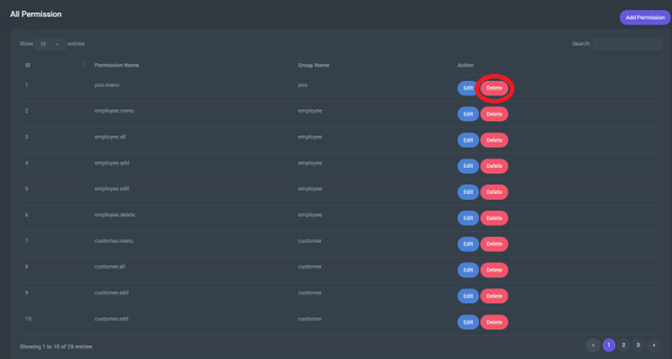

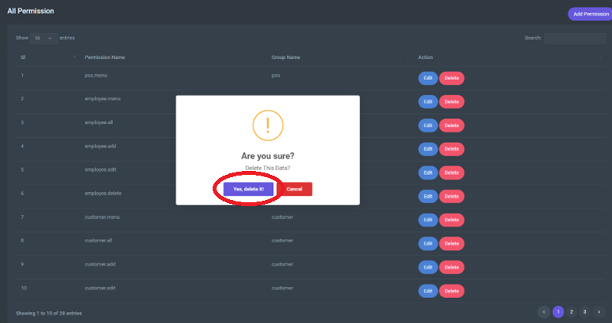

To search for permissions in the system click the search option from All Permissions.

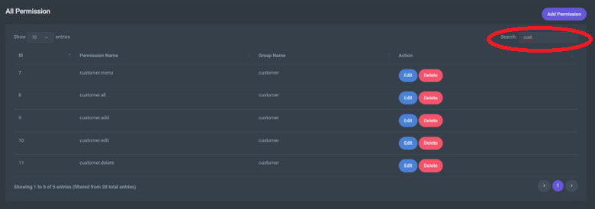

To view all the permissions, go to All Permissions from the sidebar.

To add new permissions click Add permission from All Permissions.

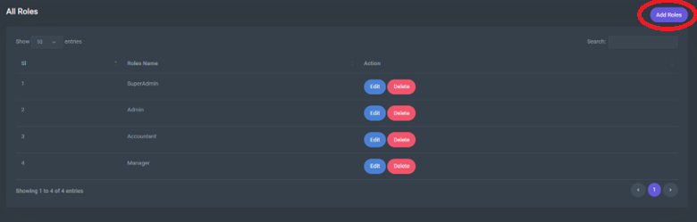

Name the role name and click the save button.

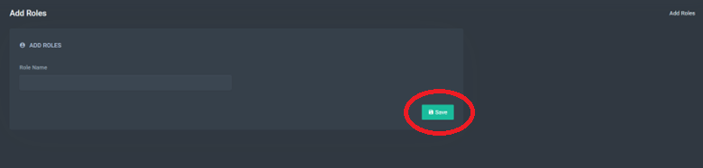

To edit role name click Edit from All Roles.

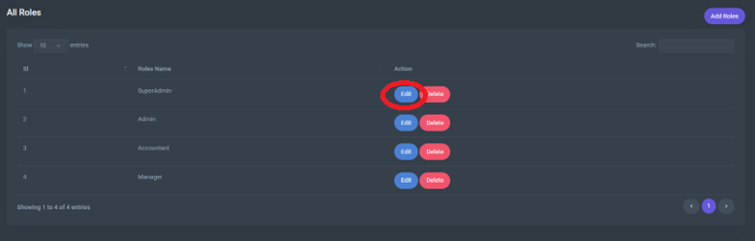

Update the existing data and click the save button.

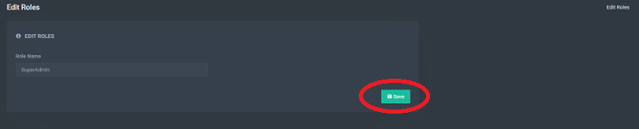

To delete a role from the system, click the delete button from all roles and click Yes to delete.

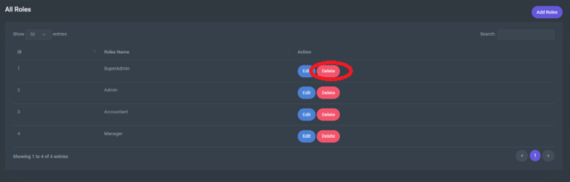

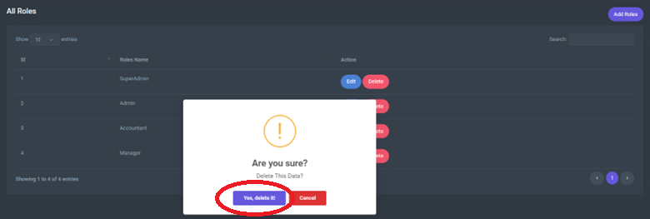

To search for a role in the system click the search option from All Roles.

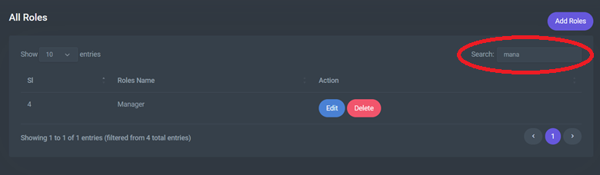

To assign permissions to a role, go to Add Role in Permissions from the sidebar.

Once the permissions are added All Roles Permission will appear.

New permissions can be assigned by All Roles Permission page also.

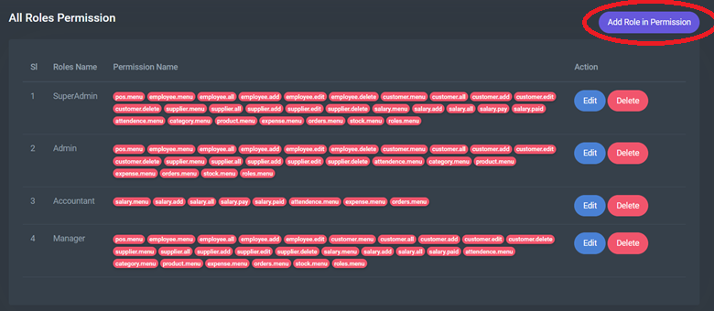

Permission for a role can be done by editing in All Roles Permission page.

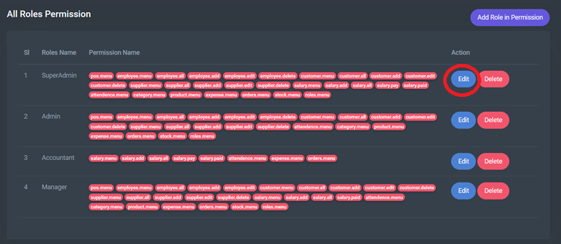

To delete Permission for a role from the system, click the delete button from all roles and click Yes to delete.

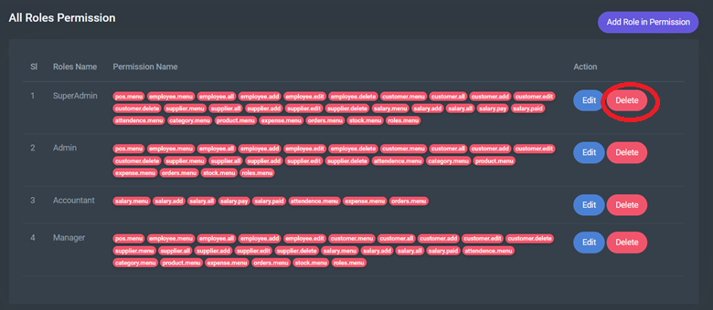

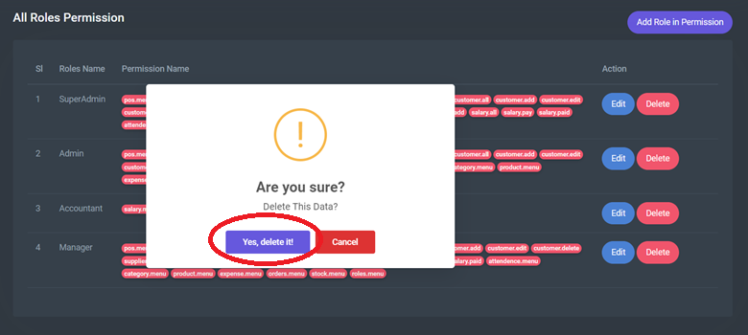

# Setting Admin Users

Go to Setting Admin User from the sidebar.

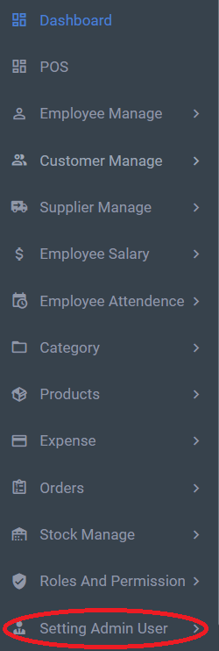

To view all the admins, go to All Admins from the sidebar.

The number of available admins is shown here.

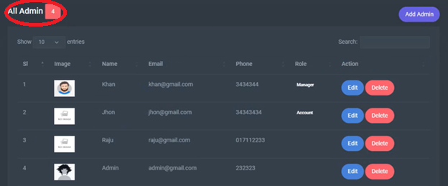

To add new admin user, click the Add Admin button from the All-Admins Page.

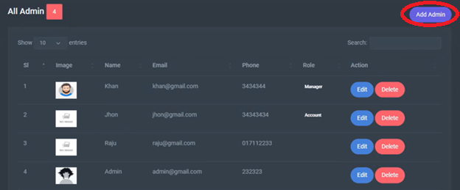

After adding data click the save button.

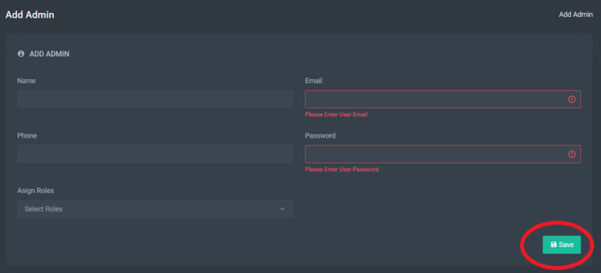

To edit role name click Edit from All Roles.

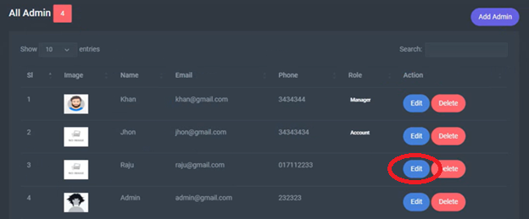

Update the existing data and click the save button.

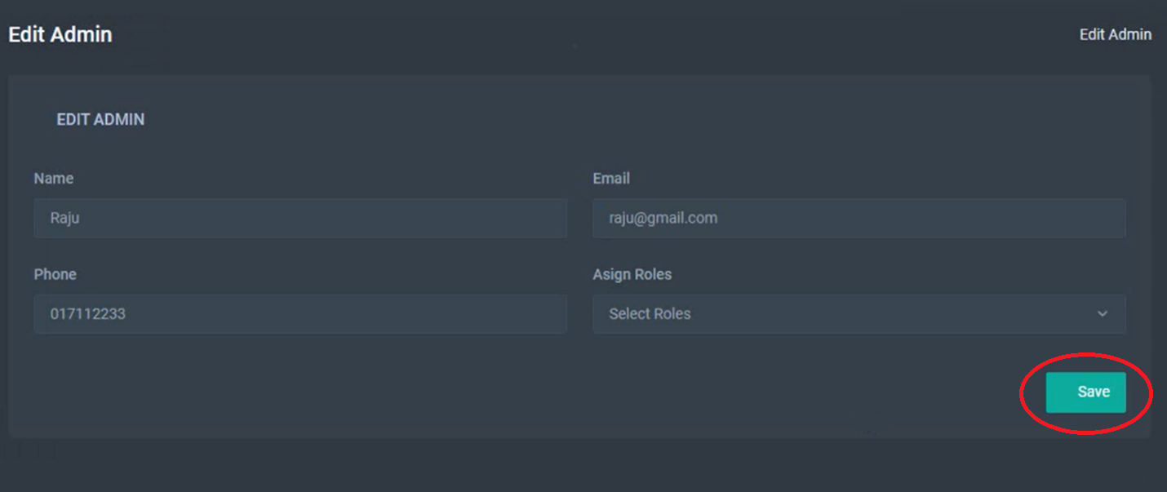

To delete a admin from the system, click the delete button from all roles and click Yes to delete.

To search for an admin in the system click the search option from All Roles.

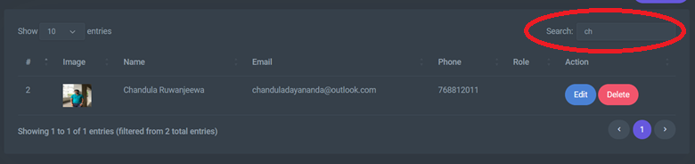

# Database Backup

By clicking the Backup Now Button backup will be created.

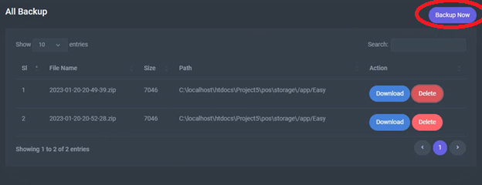

Backup can be downloaded by Download Button.

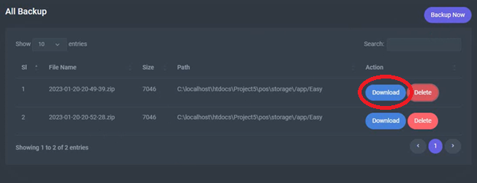

Backup can be deleted by Delete Button.

